Computing systems assignment 2

- Describe two schemas for representing negative binary numbers in a computer system
The first method involves using the left most digit to determine the sign representation of the number. 0= Positive 1= Negative
Eg +12 is written as 01100, -12 is written as 11100 (1 represents the minus)
Secondly you can use the 2’s complement process where -12 would be written as 10100 (-16+4). it uses the place values to determine the final value while incorporating the 0 and 1 rule of plus or minus but in the 2’s complement you can also use 11100 to represent -12.

- Describe what is meant by 9’s complement and 10’s complement using two 5-digit worked examples as part of your explanation of each
9’s complement: the subtraction of each digit of a number by 9
Eg: 47638
99999-47638= 52361 (you subtract each number from 9 to get the 9’s complement of the number)
10’s complement of a number is like 9’s complement as you subtract each number by 9, although in 10’s complement you +1 too.
Eg: 32287
99999-32287+1=67713
(subtract each number by 9 and then add 1)
- Describe what is meant by 1’s complement and 2’s complement using two 5-digit worked examples as part of your explanation of each

-1’s complement is used to represent negative numbers in binary form, it involves obtaining a new binary number from another one by altering the 0’s to 1’s, and 1’s to 0’s. Basically you invert the original binary number
Eg: 10011
11111-10011= 01100 (invert the original binary number)

-2’s complement: also represents negative numbers in binary form by obtaining a new by finding the 1’s complement of a number and then adding a 1.
Eg: 11011
=00100 + 1 = 00101 (invert the number and add 1)
- Outline the differences between overflow and carry. You should provide examples of each using 6-bit numbers of your choice
Overflow: occurs when the result of the calculation doesn’t fit into the fixed number of bits available for the result. Eg:
16+34
001100+100010
= 101110 (overflow and no carry as it cannot be presented as the signed value) This is a negative value due to the 1 at the start(treat it like a flag)

Carry: used to correct for carries and borrows that occurs when large numbers have to be separated into parts to perform additions and subtractions.
-13+(-7)
110011+111001 = 1101100 ( a carry occurs when you have to add two or more 1’s, 1+1= 0 carry 1. 1+1+1 = 1 and carry 1)

- Using an example, describe what is meant by exponential notation
Exponential notation: is composed of a base and an exponent. It allows you to represent repeated multiplication. The base is the factor and the exponent is the number of times the factor is multiplied Eg,
+23 .962* 10^3 = 230000
You need the sign of the number, the mantissa (magnitude of the number), the sign of the exponent and the magnitude of the exponent.
You would also need the base of the exponent and the placement of the decimal

- Illustrate how Excess N Notation works
Is uses when there is no provision for the sign exponent. You pick a value somewhere in the middle of the possible values of the exponent (0-99). Eg: 100 declared with 50, every value lower than the value will be a negative value whereas above will be a positive value
- Outline the steps taken to represent a decimal fraction as a 32-bit floating point number
- First convert the decimal fraction into binary form (12/5 = 0.24) using 10 significant bits for the mantissa by normalising the number (remember 0= positive and 1 = negative)
- Convert the whole and fractional parts independently eg 2_10 = 10_2 (binary) 0.4_10 = 0.0110011001 = 10.0110011001
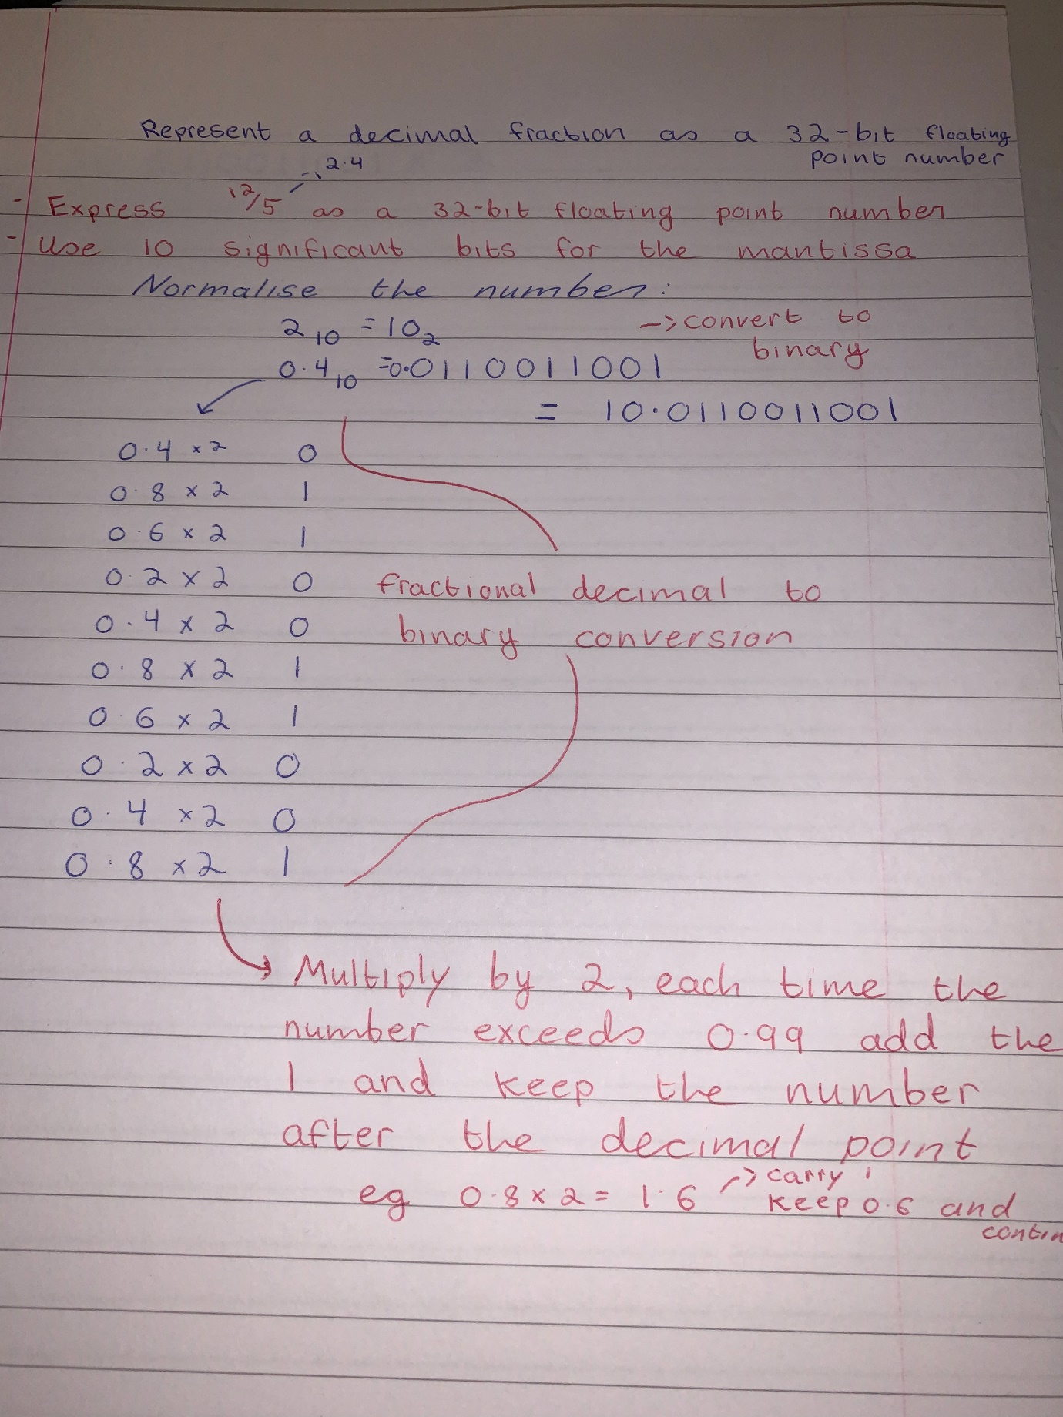
- Shift the decimal one place to the left so there’s only one non zero digit to the left, 1.00110011001
- Convert the exponent from decimal to 8 bit binary using the same method when converting the 0.4 to decimal. The exponent is 128_10 = 1000000
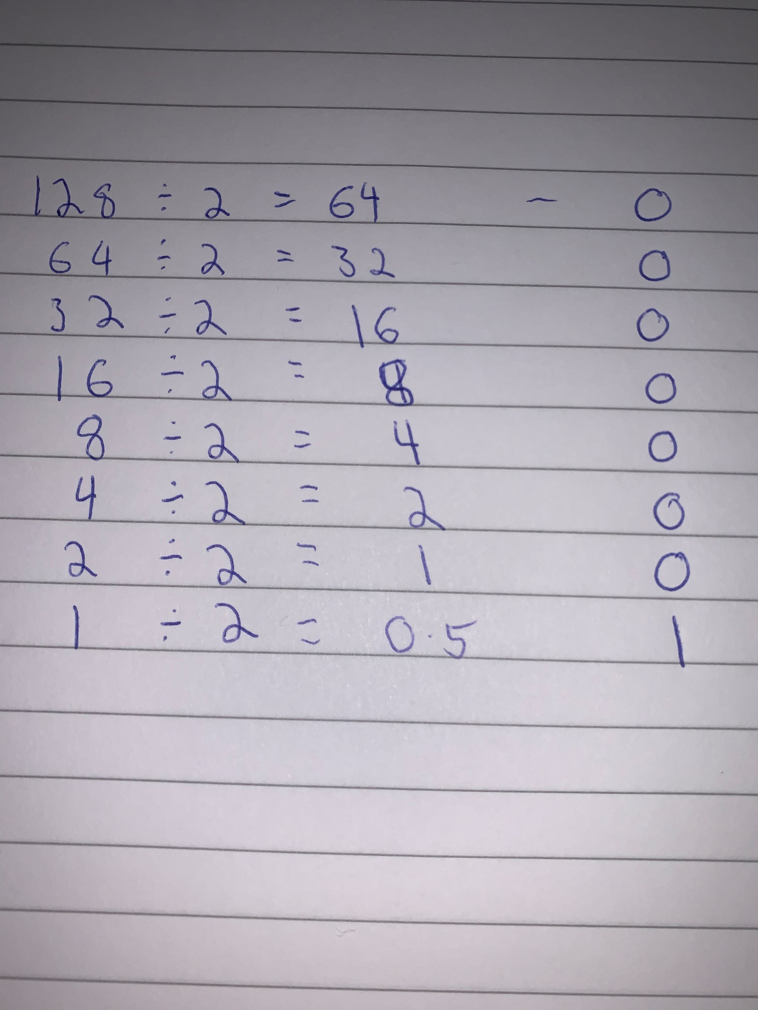
- Remove the 1 before the decimal point and make the amount of bits equivalent to 23 bits
- Combine the three elements that make up the numbers 32 bit representation which is; the sign 0(positive), exponent = 10000000 and the mantissa = 001 1001 1001 1001 1001 1001
- = 0100000000 001 1001 1001 1001 1001 1001

- Provide a step-by-step example of the addition of two floating point numbers of your choice
- You are given two numbers , convert these decimal numbers into floating point representation by using the steps in the previous
- once you finish your calculations you line up the exponents by making the smaller match the bigger one in this case it is m2
- we shift the decimal place one space to the left leaving us with 0.11000
- we add the exponents and get 10.11000
- we then normalise this into 1.011
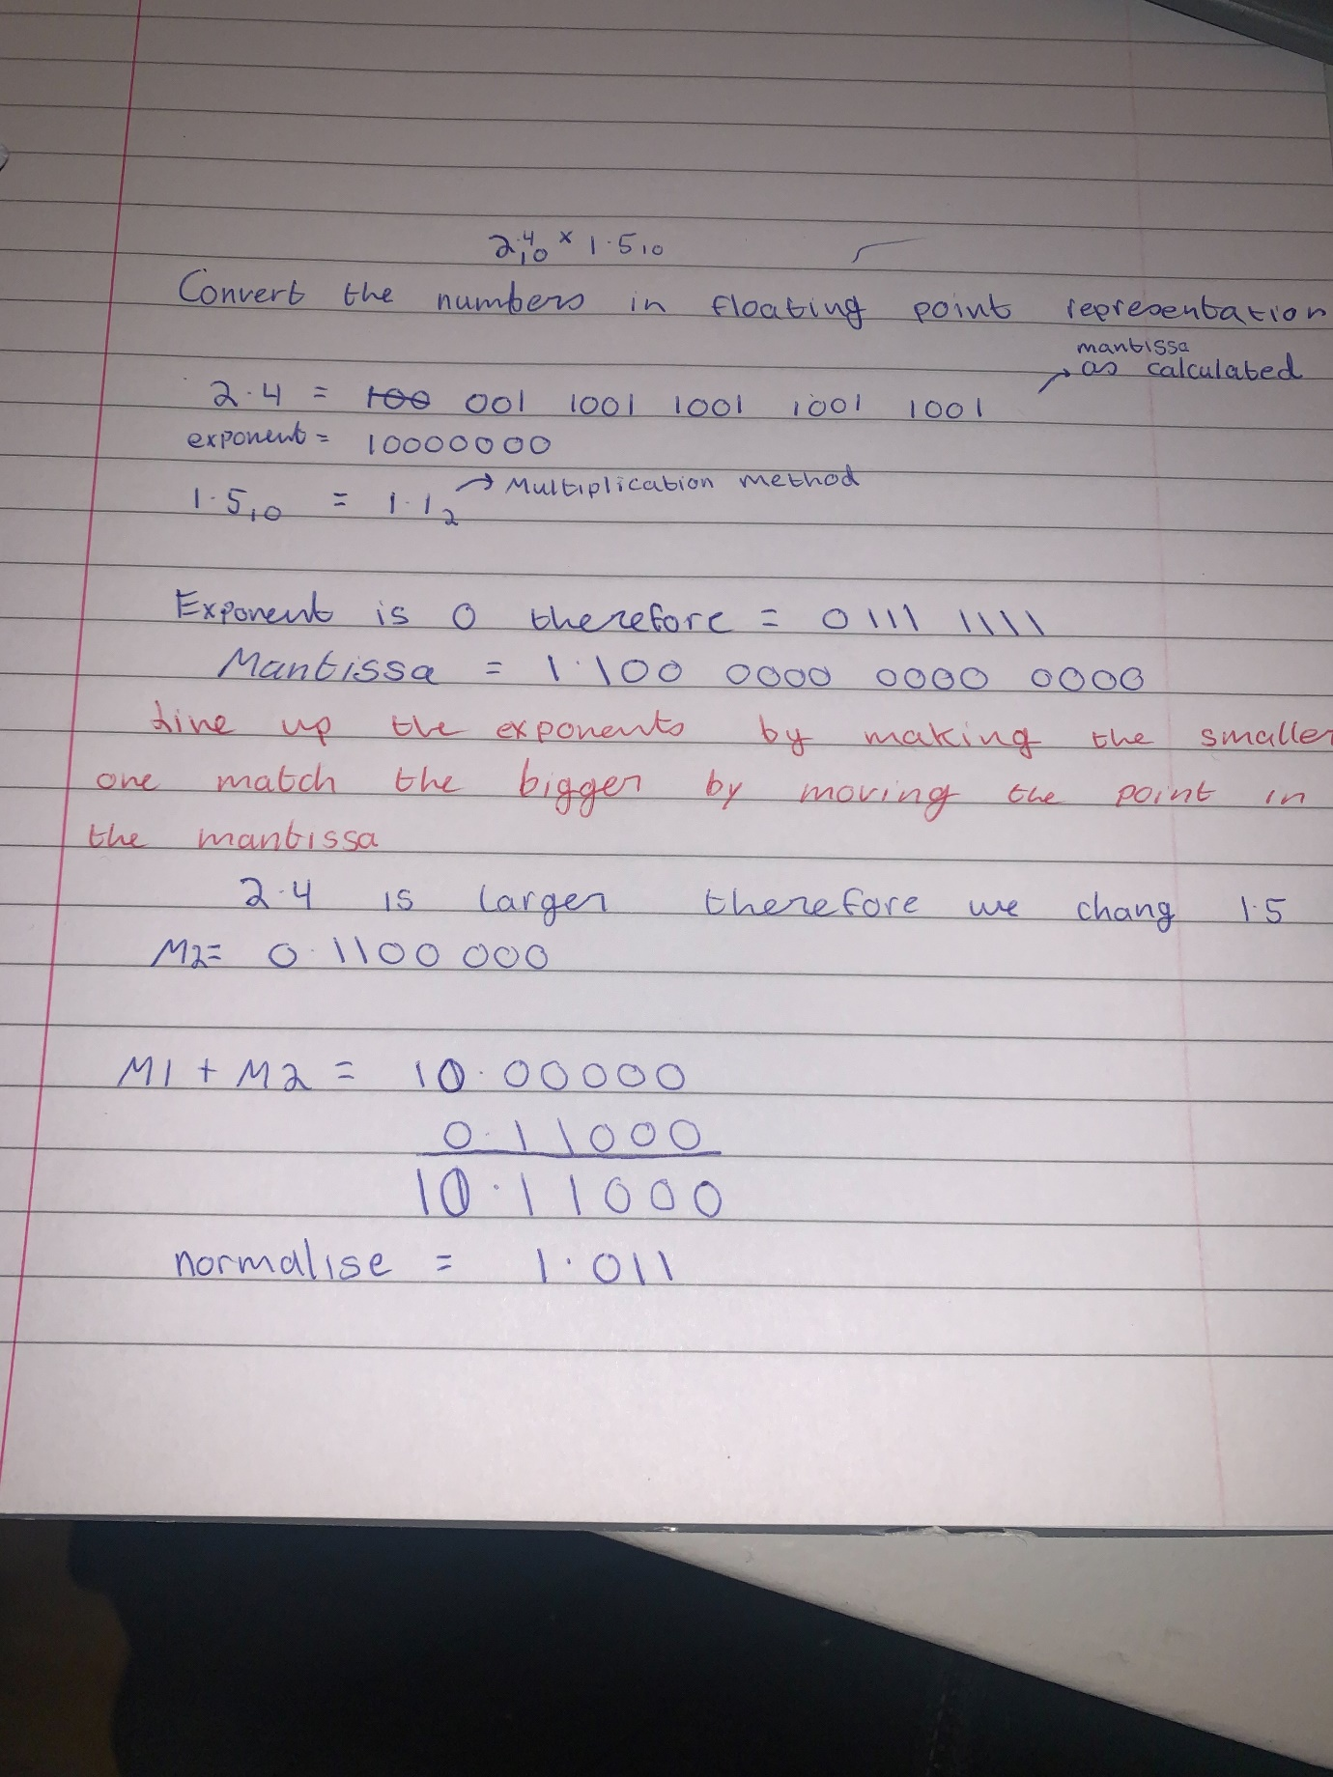

- Provide a step-by-step example of the multiplication of two floating point numbers of your choice
Formula: XY(Mx * My) * 2^Ex*Ey
2.4_10 * 1.5_10
- convert to floating point numbers as in previous examples 2.4 = 10_2 1.5=1.1_2
exponent = 10000000 = 01111111
mantissa = 1.0 = 1.1
- multiply the mantissa
- Add/subtract and adjust the exponent – take each exponent add them (10000000 + 0111111) and – from exponent (-127)

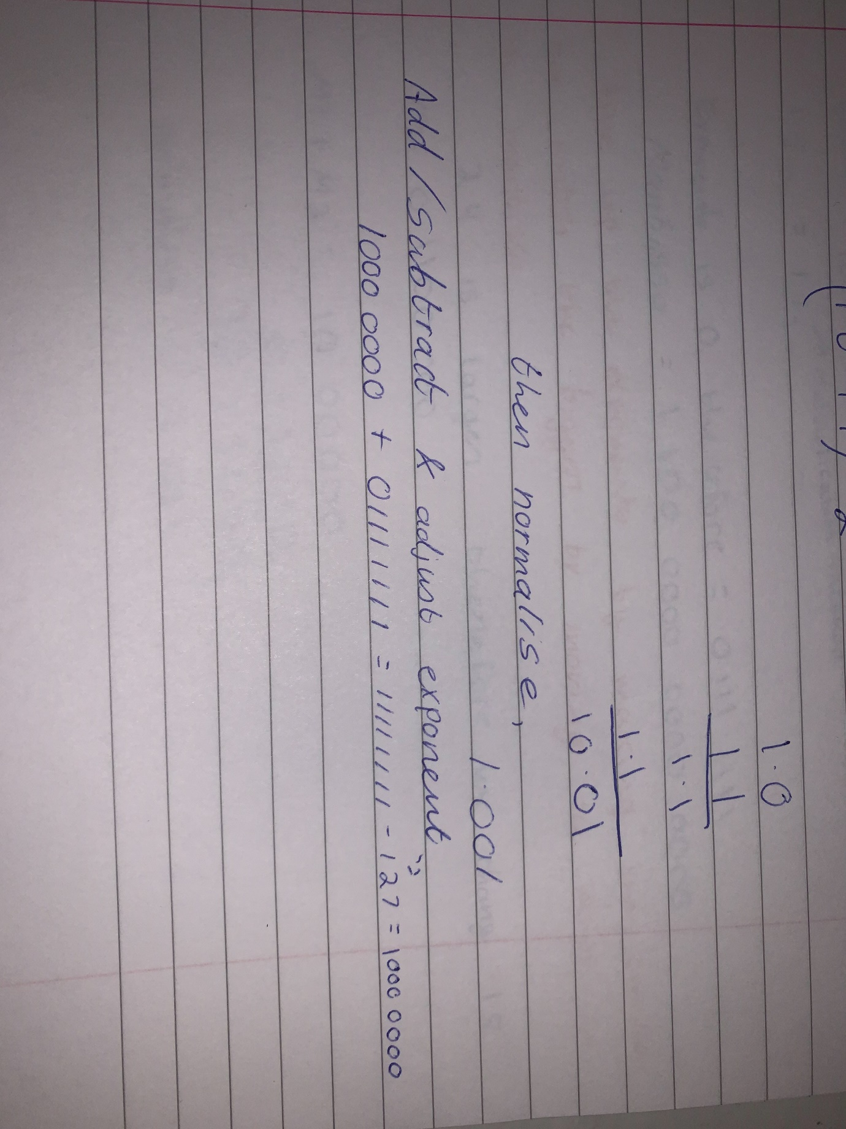
- M= 1.001
- E =10000000
- Resulting in 0 1000 0000 0001001 0000 0000 0000 ( sign, exponent , mantissa)

